**GitHub**

Overview of Git/GitHub

In this video, you’ll get an overview of Git and GitHub, which are popular environments among developers and data scientists for performing version control of source code files and projects and collaborating with others. You can’t talk about Git and GitHub without a basic understanding of what version control is. A version control system allows you to keep track of changes to your documents. This makes it easy for you to recover older versions of your document if you make a mistake, and it makes collaboration with others much easier.

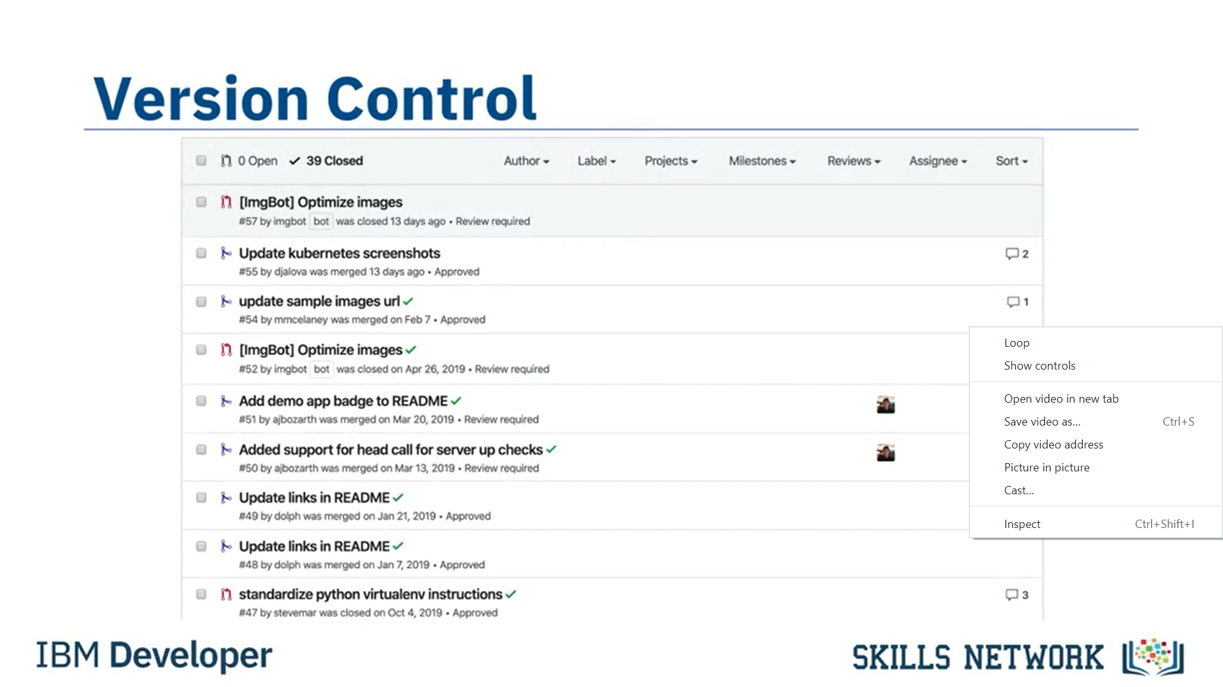

Here is an example to illustrate how version control works. Let’s say you’ve got a shopping list and you want your roommates to confirm the things you need and add additional items. Without version control, you’ve got a big mess to clean up before you can go shopping. With version control, you know EXACTLY what you need after everyone has contributed their ideas.

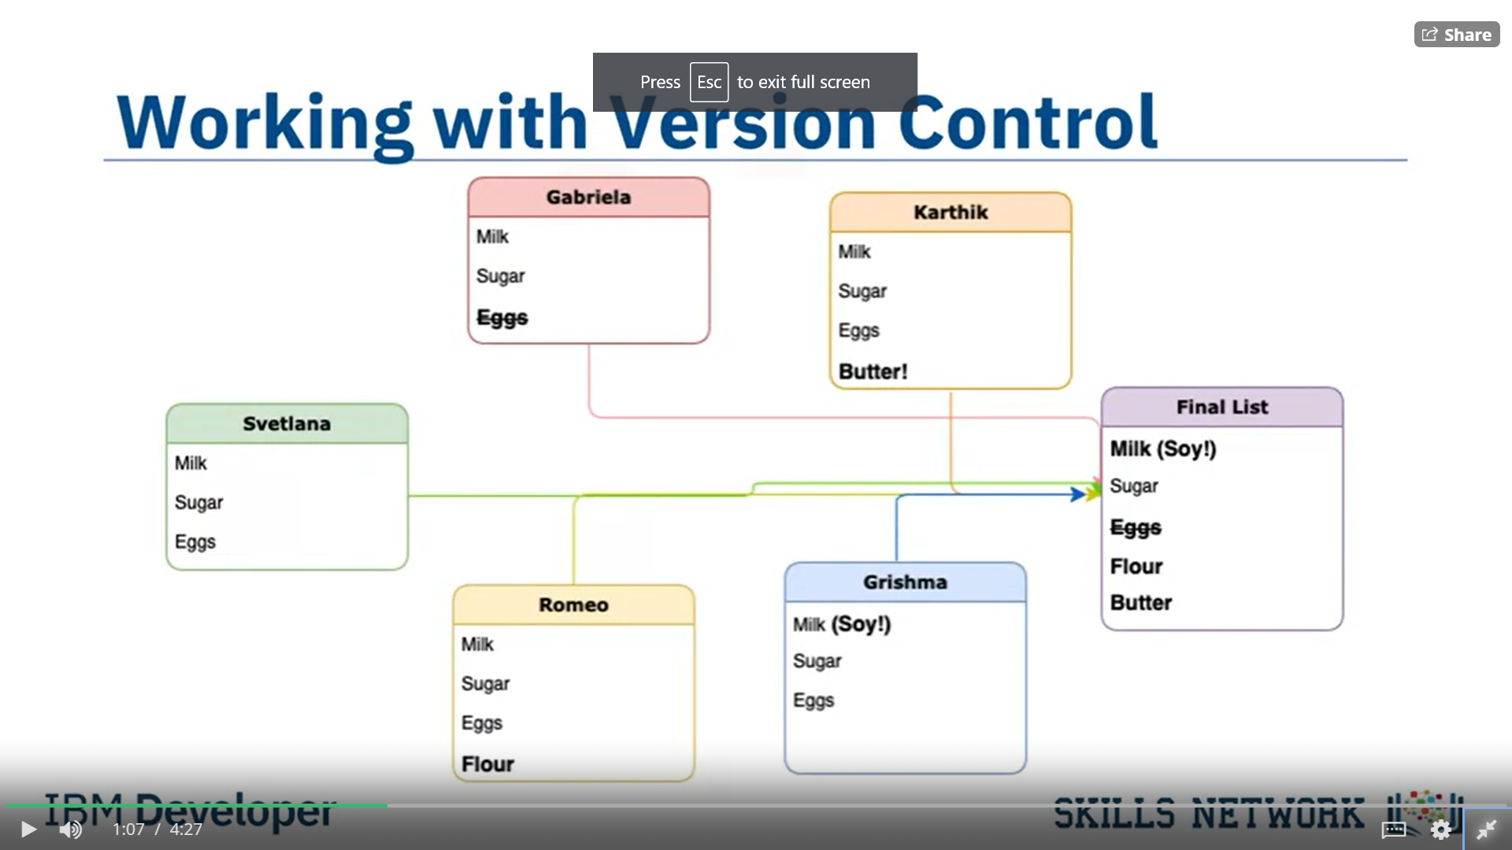

Git is free and open source software distributed under the GNU General Public License. Git is a distributed version control system, which means that users anywhere in the world can have a copy of your project on their own computer; when they’ve made changes, they can sync their version to a remote server to share it with you. Git isn’t the only version control system out there, but the distributed aspect is one of the main reasons it’s become one of the most common version control systems available. Version control systems are widely used for things involving code, but you can also version control images, documents, and any number of file types.

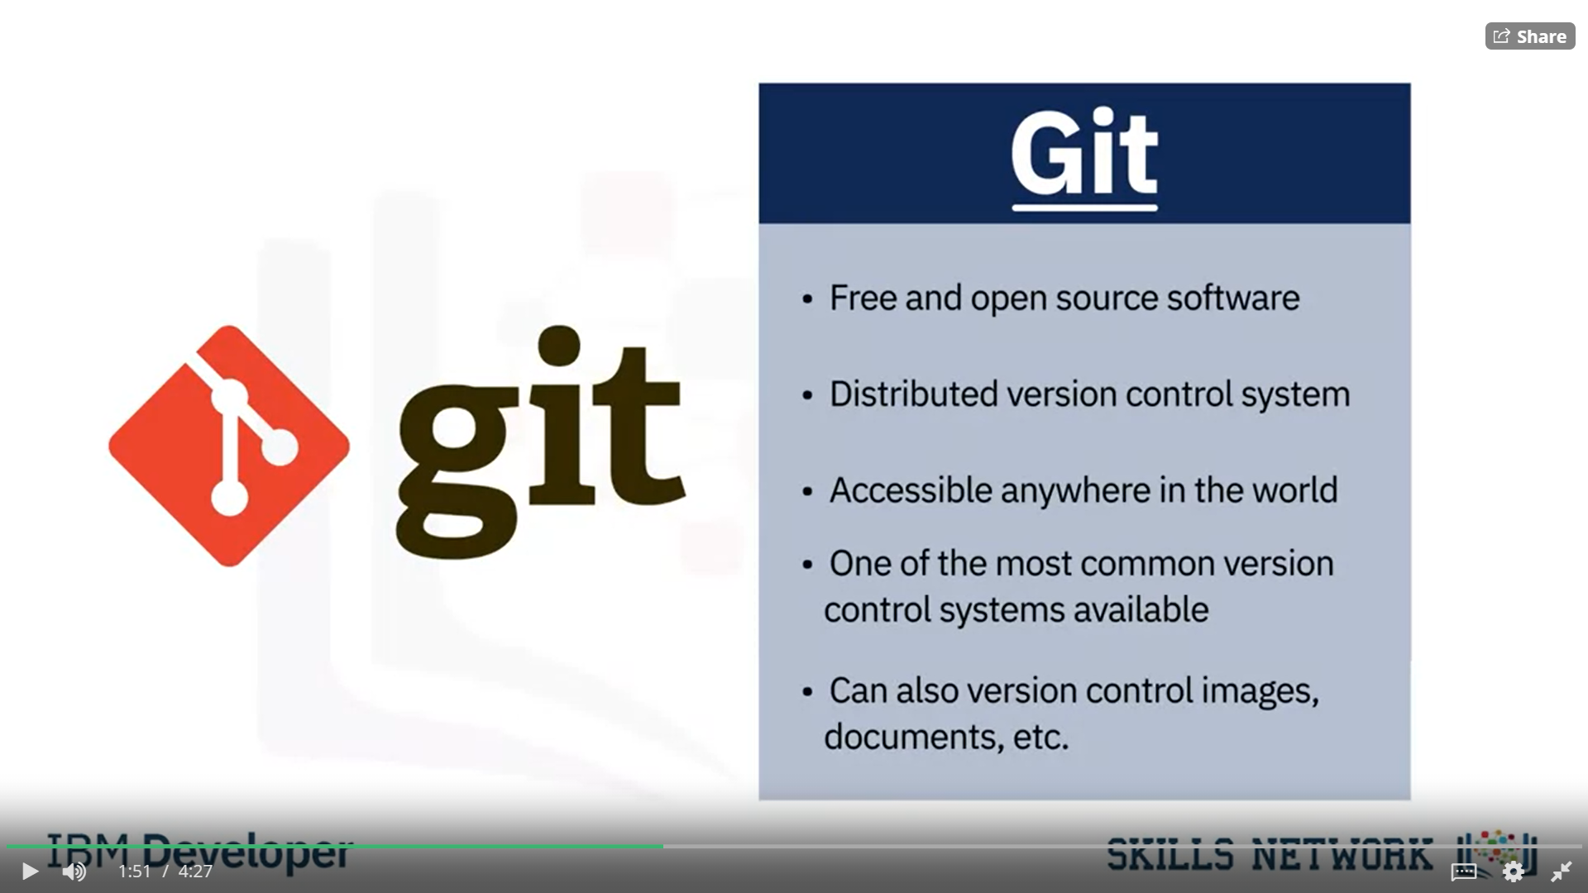

You can use Git without a web interface by using your command line interface, but GitHub is one of the most popular web-hosted services for Git repositories. Others include GitLab, BitBucket, and Beanstalk.

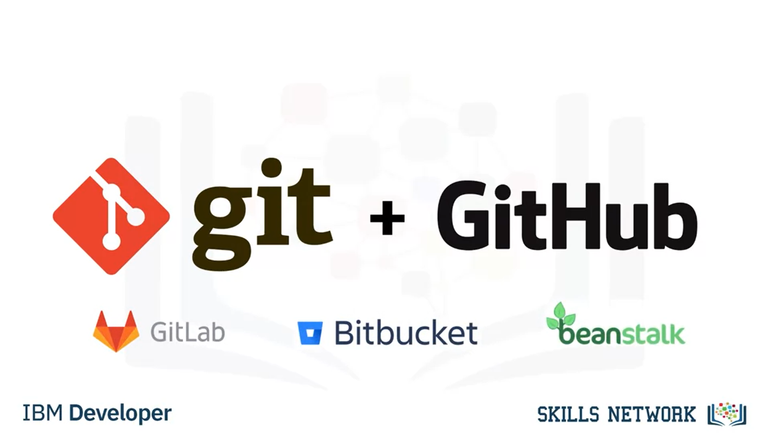

There are a few basic terms that you will need to know before you can get started. The SSH protocol is a method for secure remote login from one computer to another. A repository contains your project folders that are set up for version control. A fork is a copy of a repository. A pull request is the way you request that someone reviews and approves your changes before they become final. A working directory contains the files and subdirectories on your computer that are associated with a Git repository.

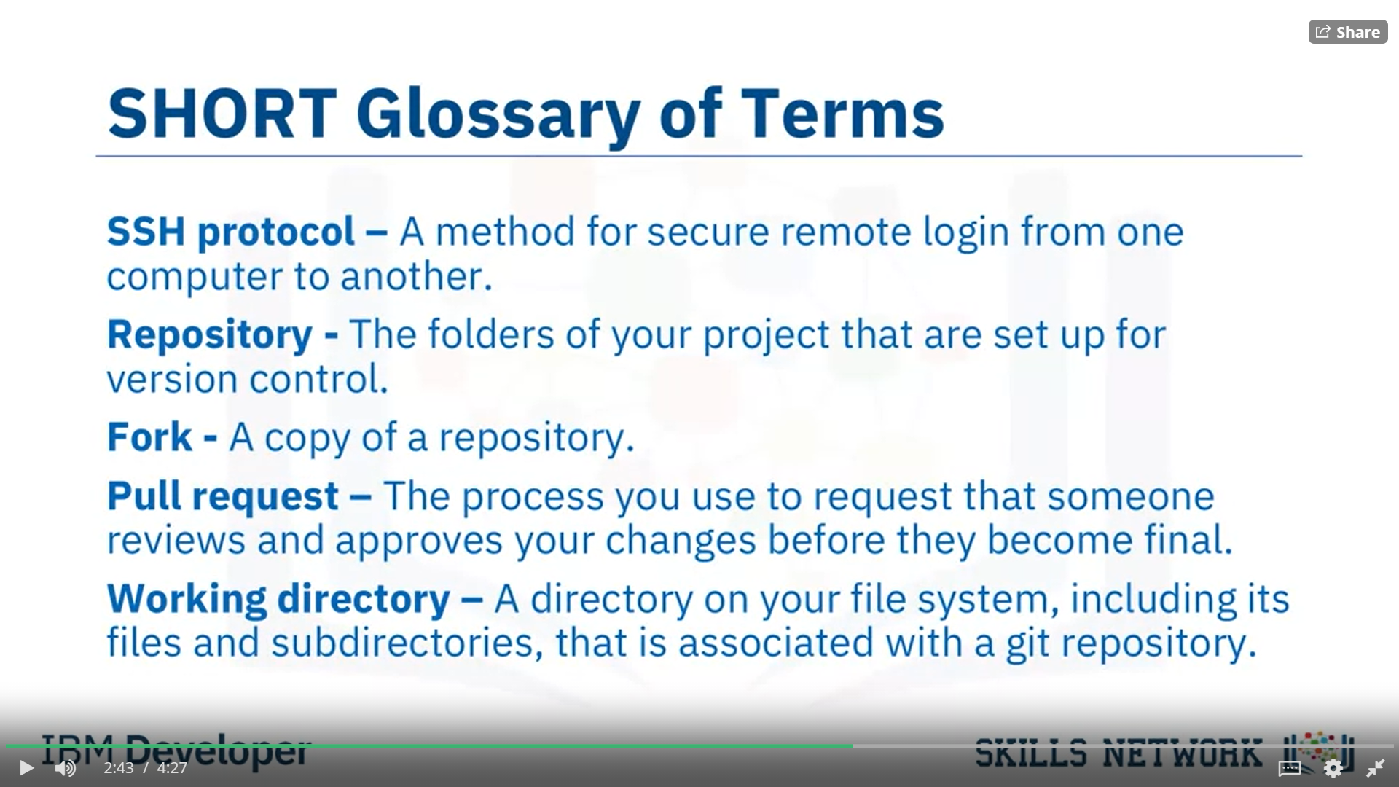

There are a few basic Git commands that you will always use. When starting out with a new repository, you only need create it once: either locally, and then push to GitHub, or by cloning an existing repository by using the command "git init". "git add" moves changes from the working directory to the staging area. "git status" allows you to see the state of your working directory and the staged snapshot of your changes. "git commit" takes your staged snapshot of changes and commits them to the project. "git reset" undoes changes that you’ve made to the files in your working directory. "git log" enables you to browse previous changes to a project. "git branch" lets you create an isolated environment within your repository to make changes. "git checkout" lets you see and change existing branches. "git merge" lets you put everything back together again.

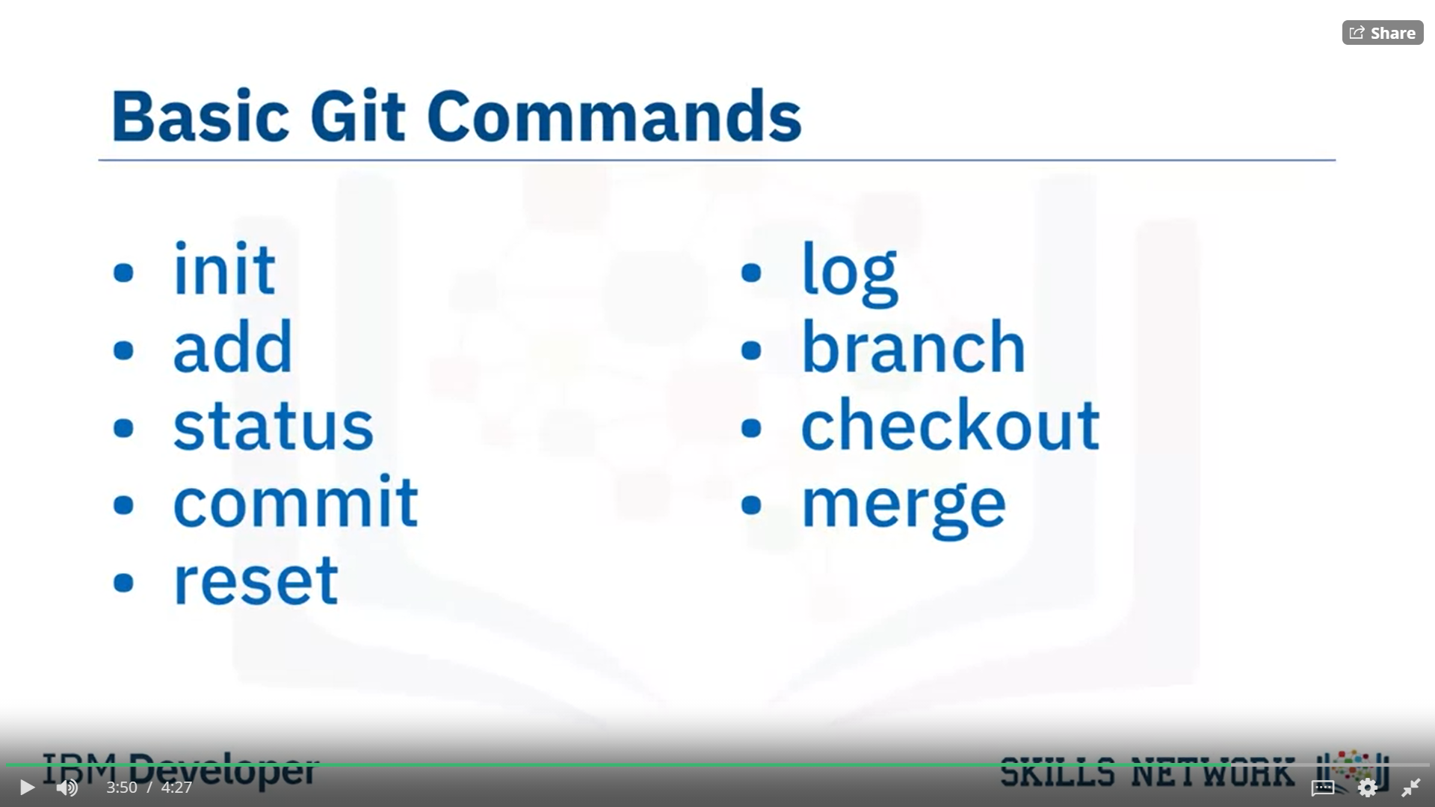

To learn how to use Git effectively and begin collaborating with data scientists around the world, you will need to learn the essential commands. Luckily for us, GitHub has amazing resources available to help you get started. Go to try.github.io to download the cheat sheets and run through the tutorials. In the following modules, we'll give you a crash course on setting up your local environment and getting started on a project.

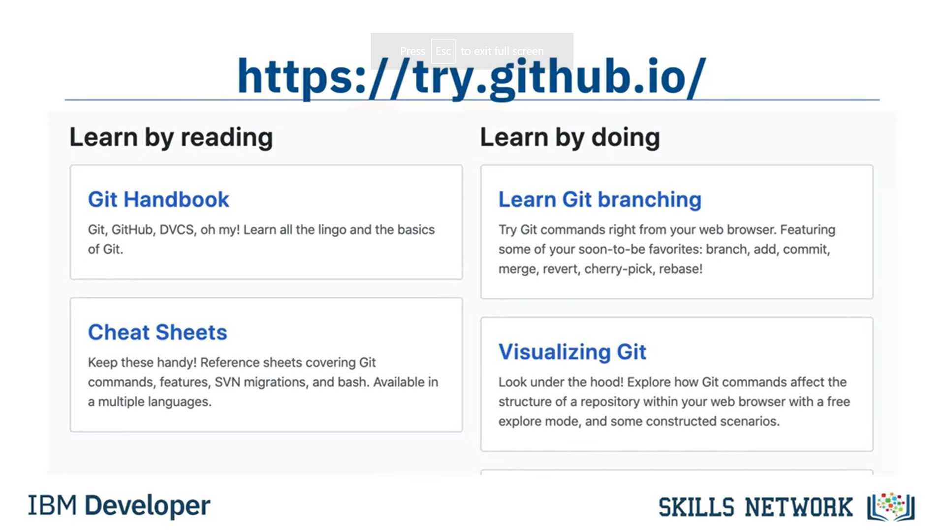

GitHub – Getting Started

In the previous video, you learned about Git and GitHub. Before you continue with this video, register for a GitHub account and log in. Let’s start by creating a new repository. Click + then click New Repository. To create a new repository, you need to provide these details: give your new repository a name; optionally, add a description of your repository; choose the repository visibility - whether you want it to be public or private; and choose the option to Initialize this repository with readme file. Then click Create Repository. You will now be redirected to the repository you have created. The root folder of your repository is listed by default and it has just one file ReadMe.md. Now, it’s time to edit the readme. You can do this in your browser. Just click the pencil to open the online editor and you can change the text of the readme. To save your changes to the repository, you must commit them. After you have made your changes, scroll down to the Commit changes section. Add a commit message and optionally add a description, then click Commit changes. The "commit changes" is used to save your changes to the repository. Go back to the home screen by clicking the repository name link. Note that the readme file is updated and verify your changes. Let’s learn how to create a new file using the built-in web editor provided by GitHub which runs in the browser. Click Add File, then click Create New File to create the new file. To create a python file called firstpython.py. First, provide the file name. Next, add a comment that describes your code, then add the code. Once finished, commit the change to the repository. You can see that your file is now added to the repository and the repository listing shows when the file was added or changed. When you need to change the file, you can edit it again. Click the file name, and then click the pencil icon, make your edits and commit the changes. You can also upload a file from your local system into the repository. From the home screen of the repository, click Add File and choose the Upload files option. Click Choose Your Files and select the files you want to upload from your local system. The file upload process may take a short time, depending on what you are uploading. Once the files finish uploading, click Commit Changes. The repository now reflects the files that were uploaded. In this video, you learned how to create a repository, edit files, and commit changes using the web interface.

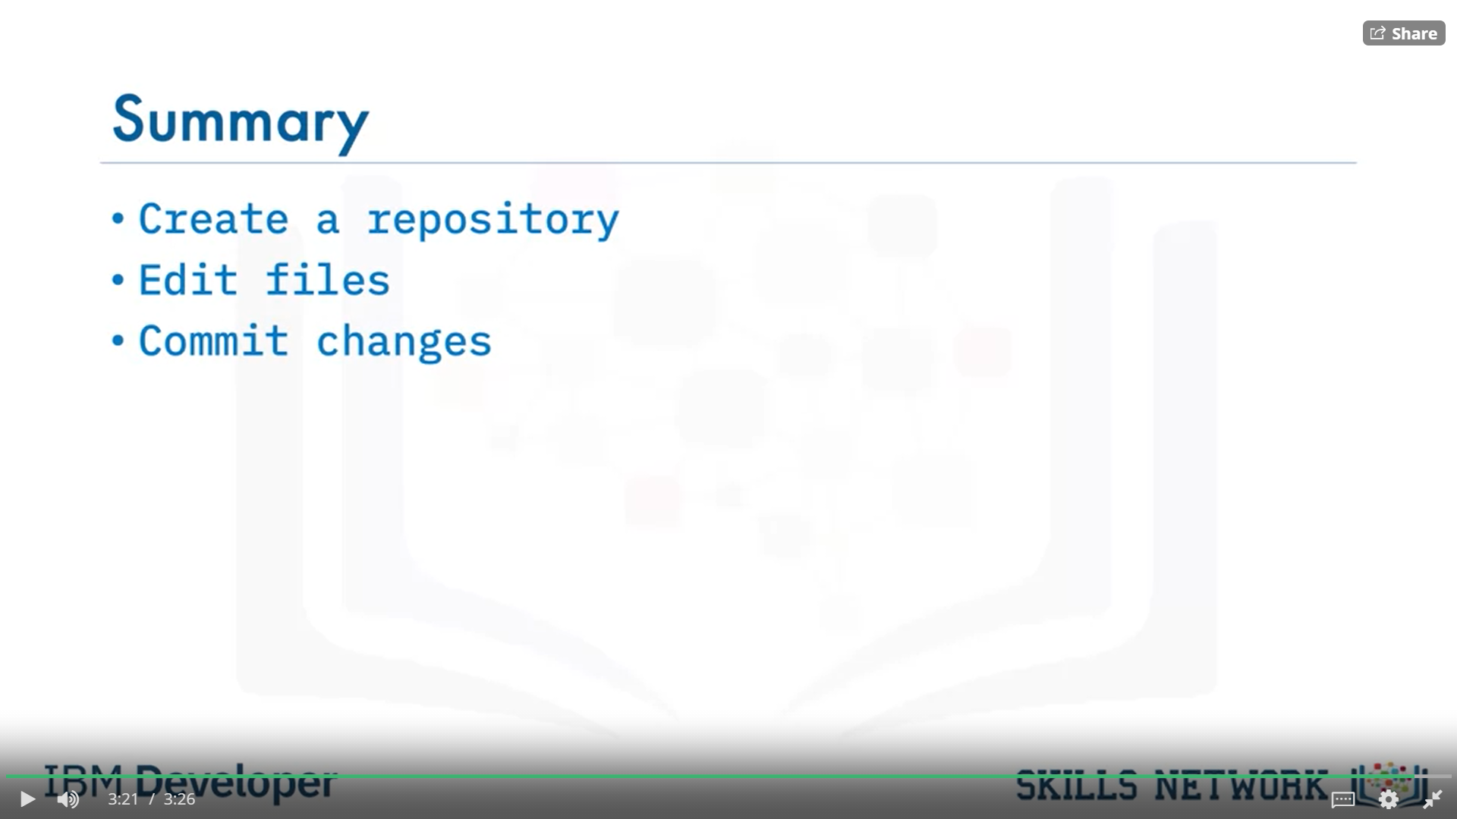

Lab 1 GitHub Lab: Getting Started (see file Module 2_Week2_Hands-on Lab_Getting Started with GitHub)

GitHub – Working with Branches

In this video, you will learn how to create and merge a branch using the GitHub web interface. A branch is a snapshot of your repository to which you can make changes. It is a copy of the master branch and can be used to develop and test changes to the workflow before merging it back to the master branch. In Git and GitHub, there is a main branch. The main branch which is called Master, is the one with deployable code and the official working version of your project. It is meant to be stable and it is always advisable never to push any code that is not tested to master. Many times, we want to make changes to the code and workflow in the master branch. That is when we create a copy of the Master branch. Let’s call it Child Branch. We will then create a copy of the workflow to the child branch in the child branch, changes and experiments are done.

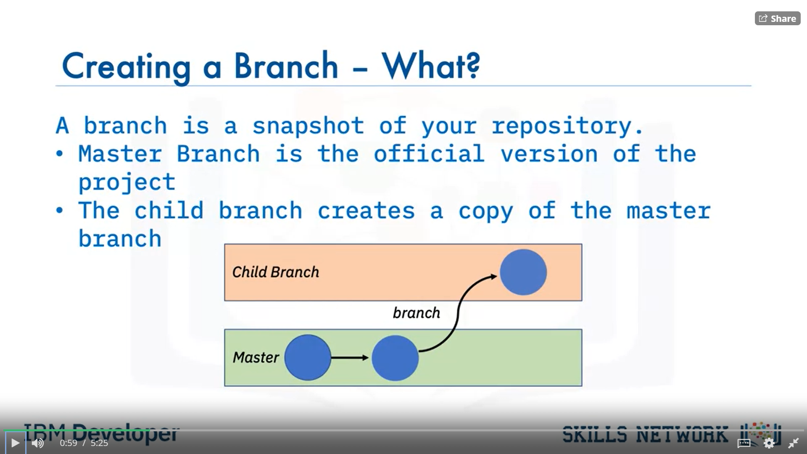

We will build and make edits, test the changes and when we are satisfied with the changes we will merge it back to the master branch where we prepare the model for deployment. We can see that all of this is done outside of the main branch and until we merge, changes will not be made to the workflow before we branched.

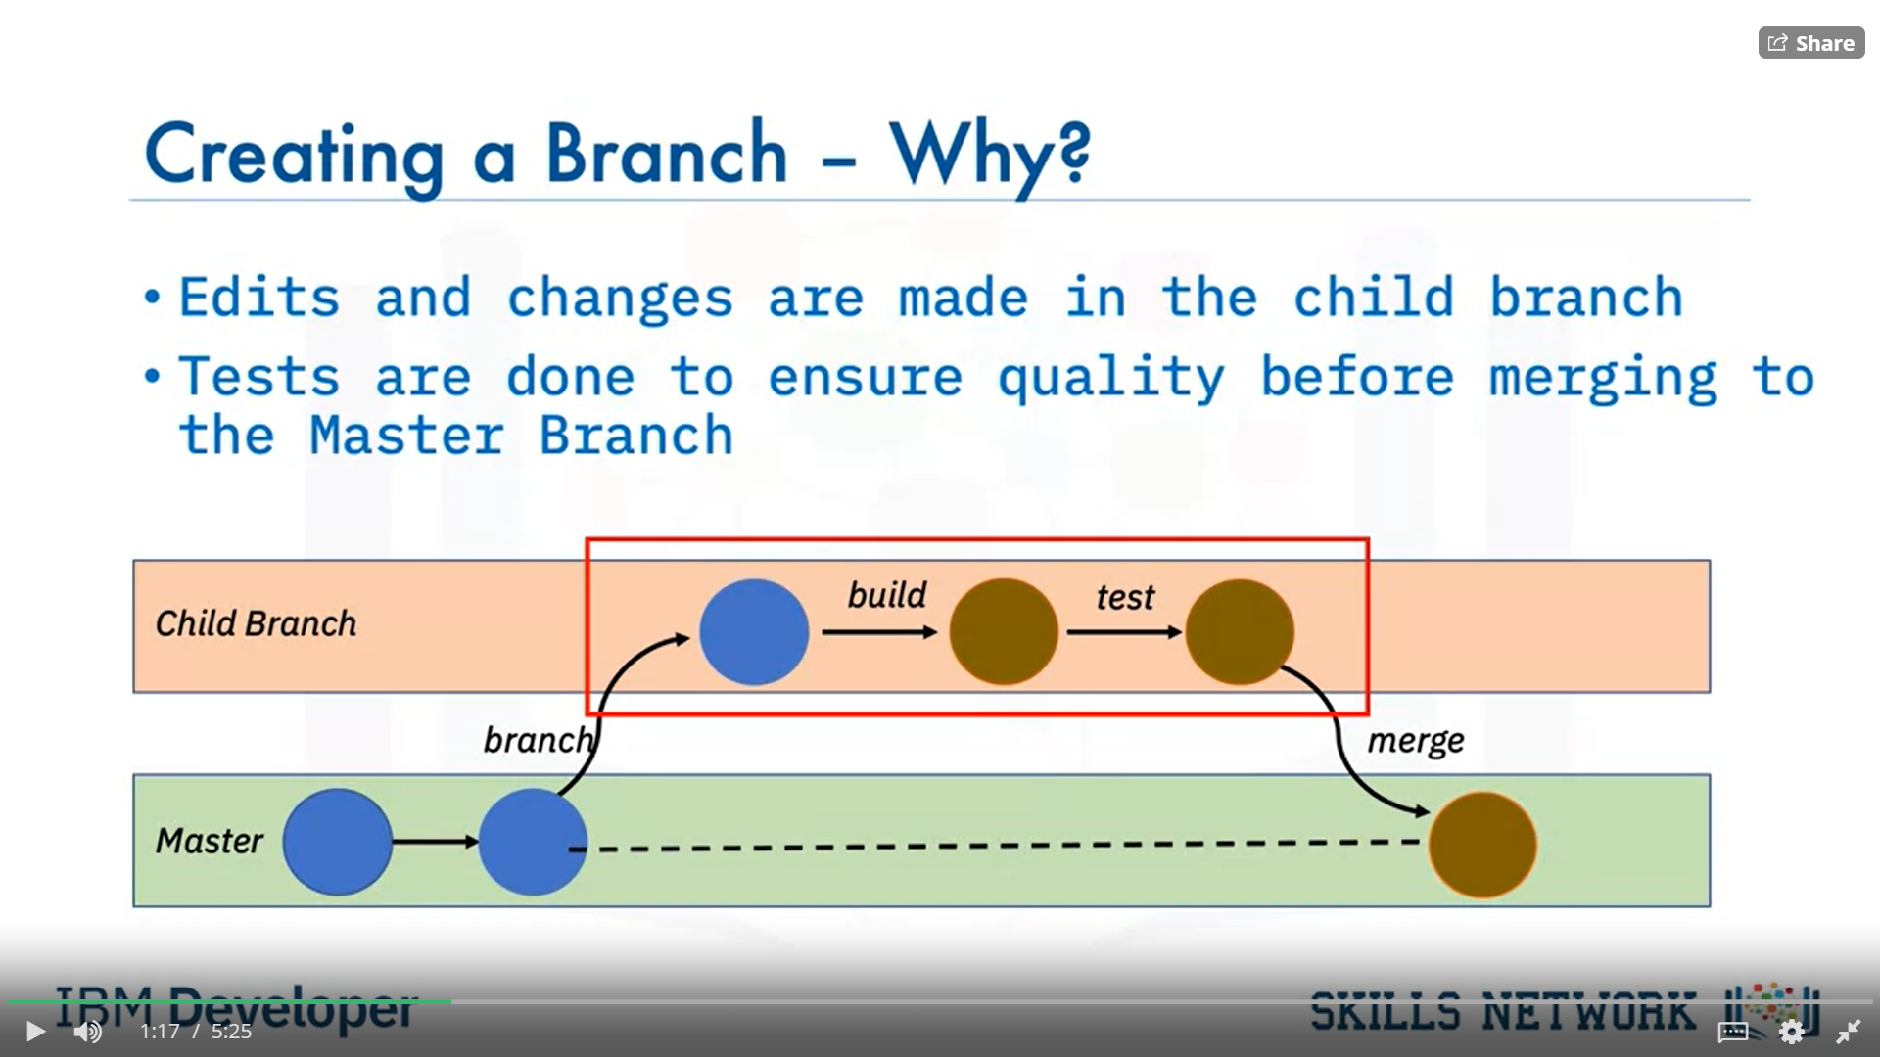

To ensure that changes done by one member, does not impede or affect the flow of work of other members, multiple branches can be created and merged appropriately to master after the workflow is properly tested and approved.

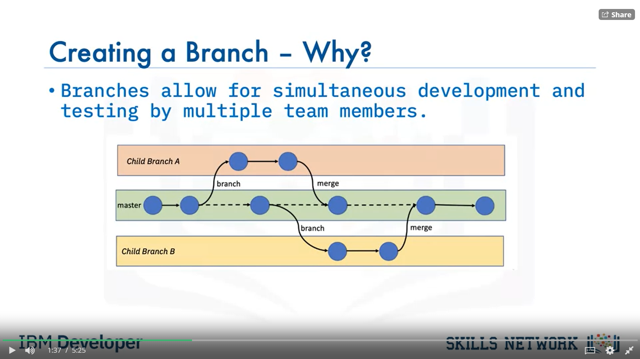

To create branches in GitHub, let’s look at this repository. There is currently one branch in the repository. I want to make some changes, but I don’t want to alter the master in case something goes wrong. We will create a branch. To do that, we will click the drop-down arrow and create a new branch. Let's name it - child branch and then we will click enter. The repository now has two branches, the Master and the Child branch. You can check this by selecting Child branch in the Branch selector drop-down list. Whatever was in the Master branch was copied to the child branch. But we can add files in the child branch without adding any files to the master branch. To add a file, make sure Child branch is selected in the branch selector drop-down list. Click on create new file. In the space provided, name the file - we will name it testchild.py and then we will add a few lines of code. We will print the statement – Inside child branch. At the bottom of the screen, we will see a section called Commit new file. Commit messages are very important as it helps to keep track of the changes that were made. It is important to add a descriptive commit message so that other team members can understand it. Here we will add a commit message, Create testchild.py, then we will commit the new file. The file gets added to only the child branch. We can check this by going to the master branch by clicking ‘master’ from the Branch selector menu and here we can see that the new file is not added to the master branch. After we have created the new file, tested and made sure that is up to standards. We then want to merge the changes in the child branch to reflect in the master branch. To merge the changes, we will first have to create a pull request, also known as a PR. A pull request in simple terms is a way to notify other team members of your changes and edits and ask them for review so they can be pulled or merged into the master branch. Pull requests are the heart of collaboration on GitHub. When you open a pull request, you’re proposing your changes and requesting that someone review and pull in your contribution and merge them into the target branch. Pull requests show the differences of the content from both branches.

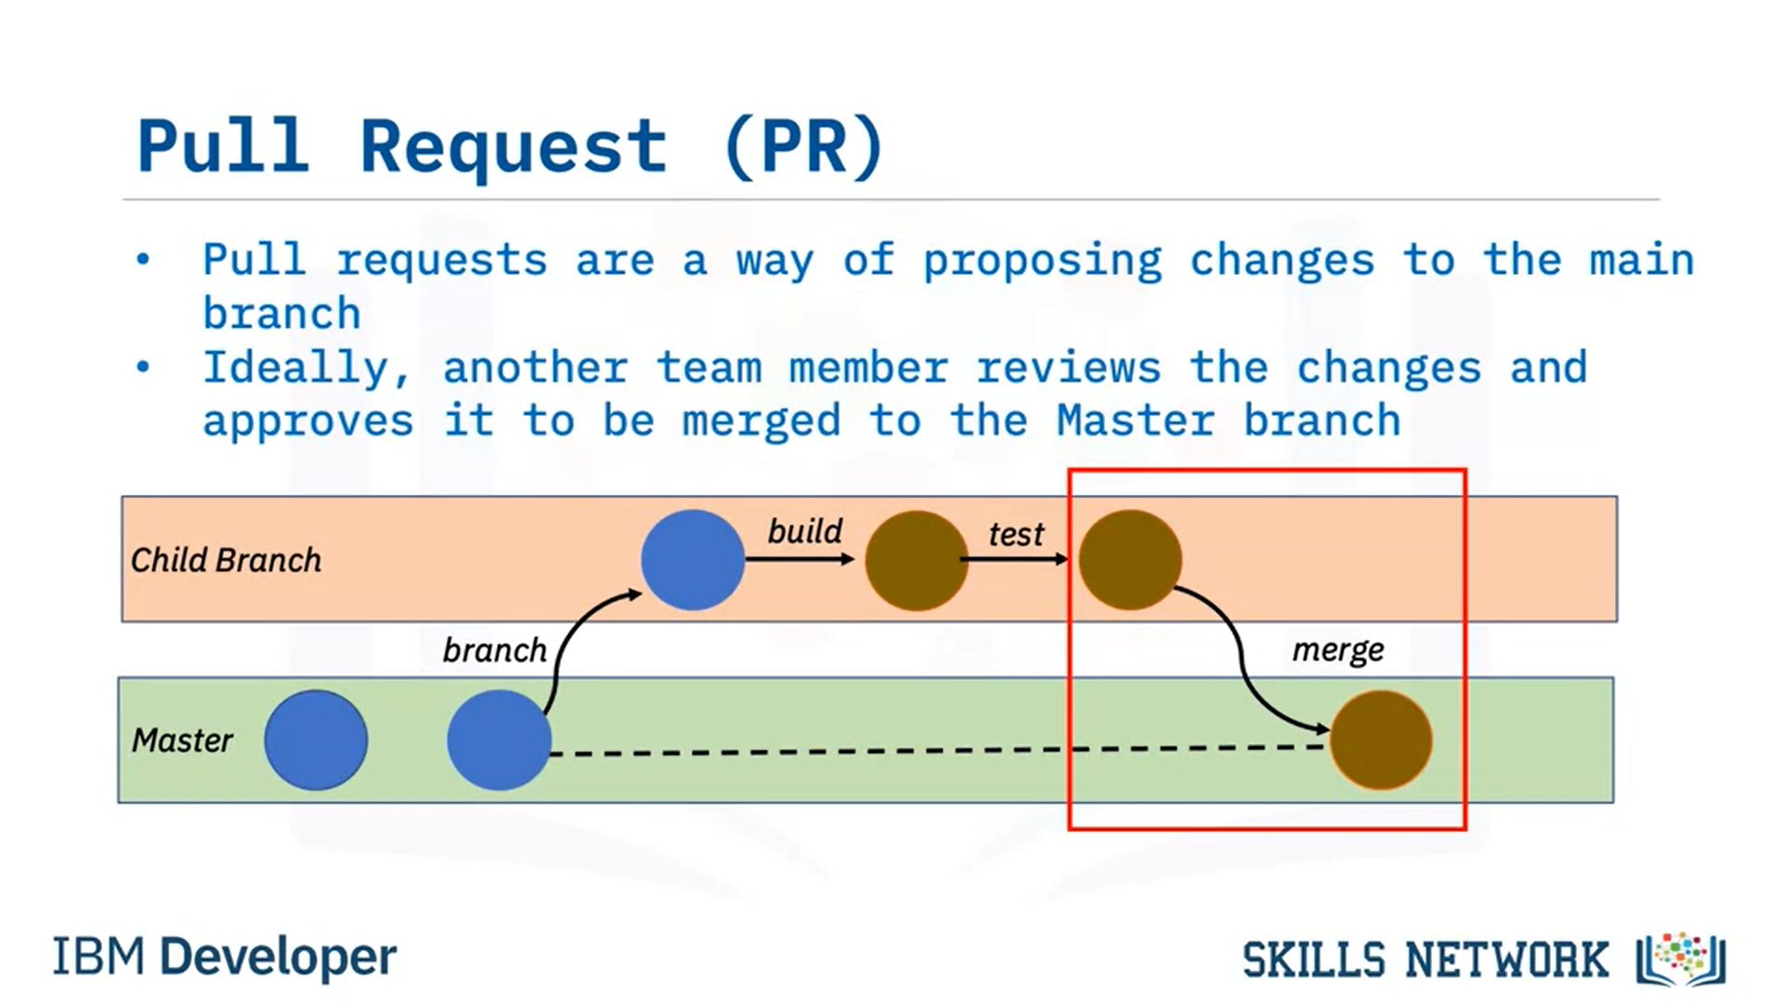

To open a pull request and see the differences between the branches, click on the Compare and pull request button. If you scroll down to the bottom of the screen, you will see something like this that shows you the difference between both branches. As you can see on the screen it shows that one file has changed and the file has two additions, which are the two lines we added to the file and 0 deletions. We will now create the pull request. Add the title and an optional comment for the pull request. Click Create Pull request to create the pull request. You can assign team members to review and approve pull requests. On the next page you will see this image. If you are okay with the changes, click on Merge pull request and click confirm. You will get a confirmation that the pull request has been successfully merged. You can now delete the branch if you no longer need to make any edits or add new information. Now, the child branch has completely merged with the Master branch. You can check the Master branch and we can now see it contains the testchild.py file. You should now be familiar with how to create and merge branches using the web interface.

Lab: Branching, Merging and Pull Requests on GitHub (optional) ((see file Module 2_Week2_Hands-on Lab_Creating and merging branches in your GitHub repo)

Git and GitHub via command line (optional)

Welcome to again, introduction to Git and GitHub. It's very basic. If you have absolutely no clue, then this is for you. Otherwise it's maybe boring. I'm just telling you how I'm using Git, and I am able to survive in most of the cases with that knowledge. Sometimes I have to read the documentation for a more advanced stuff, but in let's say, 80 percent of the cases that I will tell you now is sufficient. Let's actually start using GitHub. It makes things a bit more easy. There's also competition to GitHub. This is GitLab. GitLab is particular interesting because the whole system behind GitLab is open-source. This is a hosted version, but you can have the whole system on-prem, and also purchase support from GitLab. Those guys are partially in Berlin, so they are pretty cool. Anyway, let's start with GitHub here. What I will do now is create a repository. A repository is the location where your stuff goes into. Let's call it, I don't know, demo, and we can choose whether we want to create a public or a private repository. That repository is remote, that's hosted at GitHub, and let's initialize with a README. Let's skip gitignore for now, I will show you that later. We create now repository. Once this is created, it's very easy to have a copy of this repository locally. There are two options: one is cloning it via HTTPS or via SSH. I'm always using SSH, it just to make things a bit more easy. The only thing you need to do is you have to add your public identity to GitHub. I can show you that later. Now, the only thing we need to do is we go to empty folder, and then we say git clone, and this link. What now happens is the contents of this is copied to my machine. Here, I have to specify my password for my SSH identity, so that's something I need to explain you later. If you know, go to demo. You will see here the README file, and you see here there is content of the README file. Now, let's add a file. You see here there's only the README, and the.git folder. Please never ever touch it. Let's create another file. Let's say, vi test.txt, and hello, this is a test. Now, we add this to the repo. First of all, we say git add test.txt. Now, if we say now git status, then we see that this file is now in the so-called staging area. That's something in-between your local folder and your local repository. You have a local folder with the contents, you have a local repository, and you have a remote repository. Personally, you work with your local repository, and all the other guys working together with you are working also with their local repositories, and do sync all your contents with the remote repository. Now, we want to commit or let's do something else. Let's say, we create a file test2, and we say git add test2.txt. Now interestingly, if we now say git status, those are both in the staging area. Now, if we say git commit, and we say message initial commit, and that is now in our local repository on this machine. The idea is why you have the staging area, you can control which files go into a commit because let's say, the atomic entity here in git is a commit, so everything is around beat on the commit. You can yet definitely control which files are going into a single commit. Now, what you want to do is you want to push the contents of your local repository to remote repository. Because if you now go to this here, to this GitHub project, you see that there is no additional file. We say now, git push. What now happens is, I again have to provide a password. I don't have the key agent that running. Now, you see here we have committed this local change in the local repository to remote repository. Now, you can see that you have these two files here. If you click on that "File", you'll see first of all the content, and also you'll see here which commit was responsible for adding this file. Another interesting thing is if you are starting from scratch, you can also do the following: Now, let's delete this project, and this is a bit hard. Just to make sure you don't do that accidentally, so delete this repository, and you have to say demo here, although I think you have to type the whole thing here. Now, this project is deleted. Let's do something else. Let's create a new repository, but now let's init a repository on my machine. Let's call it demo again. We don't initialize it with a README. We say create repository. If you're lucky, GitHub will show us how to do it. Yeah, here. Let's actually do it ourselves. Let's get rid of the demo folder, and let's create it again. Now, do what they tell us. We create a README, and let me say, git init. Now, we have it initialized because now we have the.git folder which you never ever should touch. We say git add README, but we can also say git add., so it's adding everything which was in our folder. It's only the README.md, and then we say, git commit as usual, test or whatever. Now, we can't say git push now. If we say git push, it doesn't know where to push it because actually we haven't told this local folder that it should connect to remote repository. That we do with git remote add origin, and that's the URL of our project. Then we can say git push u origin master, and that's basically it. We have to re-enter the password for my RSA key, and if you're lucky, and everything worked fine, we can now go to the project, and we should see the README file, which is the case. That's it for now.

That's the first part. In the next video, I will show you how to do branches, and actually also how to create a pull request. Thanks for watching, and see you later.

Pre-requisites on command line interface (optional)

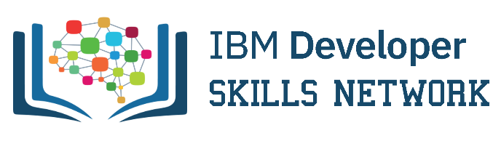

Pre-requisites for working with GitHub on local machine:

**BASH Installation**

*For Windows:*

[GitBash Installation](https://cf-courses-data.s3.us.cloud-object-storage.appdomain.cloud/IBMDeveloperSkillsNetwork-DS0105EN-SkillsNetwork/labs/Module2/GitBash_Install.md.html)

*For Linux/Unix:*

For Linux systems installing Git is easy. If you are using a Debian-based distribution like Ubuntu, you can use apt install:

$ sudo apt install git-all

For Fedora, RHEL or CentOS, you can use:

$ sudo dnf install git-all

*For Mac:*

Open the Terminal

Install homebrew if you don't already have it, then:

$ brew install git

**SSH Key generation**

[Generate SSH Key](https://cf-courses-data.s3.us.cloud-object-storage.appdomain.cloud/IBMDeveloperSkillsNetwork-DS0105EN-SkillsNetwork/labs/Module2/GitHub_SSHKey.md.html)

Author(s)

Romeo Kienzler

Configuring SSH access to depositary (optional) (see Module2_Week2_ Adding SSH Key to GitHub)

Git and GitHub via command line instruction (optional) (see Module 2_week 2_ Creating Repository in GitHub)

Branching and merging via command line (optional)

Welcome back to the second part of my little GitHub for Dummies series. One thing I forgot on the last video is how to sync if someone else has made a change. Okay. Let's consider this repository here, we have nothing inside; so this is actually the remote repository here on GitHub. So, we will again create a little README file, add "README: and then we say "git add" and then we say "git commit" "blahblah" and then "git push". Then we have the README file here, and now let's create a new file in the remote repository that's something which will happen also if someone else pushes something to that repository. You will see a new file... and this is now only in the remote repository and not in my Local (repository). You see here, there's only the README and not the new file. To obtain this new file, you say just "git pull" and then you see here the new file is also here. And yeah, that's basically it. And then interestingly let's say you are, for example, working on a huge sub-project in the repository and you don't want to interfere with the main work going on. The main work is basically called a branch, which is "master" You can create your own branch. So you can say, "Git branch mybranch" for example. So, then you say "git status" we still see that we are here on the master branch. Now we say "git checkout mybranch" and now, see, we are switched to my branch and now we say "git status" and you also see here we are on mybranch. Now what I do is... here we have those two files, and we say "# stuff on branch" here and we say "stuffonbranch.txt" so "git add stuffonbranch.txt" then "git commit" and "bla" and "git push" Ah yeah, we have to also create this branch remotely. So, and now we push it to a remote branch. Now we can actually see that mybranch has been created here and you see here the file stuff on branch which is not on the master. So, what we do now here is we switch back to the main branch. So that's "git checkout master" and then we say "git merge mybranch" So this has been automatically merged so you see here we have stuff on branch also in my local folder here. But we see here it is still not in the master, ok? So we say "git push" and if you now refresh you see stuff on branch. So what happened here is we have merged from the local branch repository into the local master repository and now we push the contents of the local master repository to the remote master repository, and that way we have merged branch back into the master branch. So, that is all for now here. In the next video, I will show you how to actually create pull requests and contribute to foreign repositories.

Lab 2: Branching and merging via command line (optional) (See Module 2_Week 2_Add file to Repository in GitHub)

Contributing to repositories via pull request (optional)

Ok so this is the last video now, on the series 'Git for Dummies'. So, I just want to show you how to fork a repository on github, how to commit to a forked repository and how to create a pull request. So lets consider you want to contribute to the very best and most important github repository on the planet. This is the coursera repository in the IBM organization which I’m maintaining, and lets assume you have found an error in one of those software components. I mean its impossible there is an error but just consider there is an error and you want to fix it. So what we can actually do is, you can either ask me to give you commit rights to that repository but its better if you just create a fork of this repository and then commit to your repository, to your fork and create a pull request. Let me show you how that works, so you see here 529 other folks already forked this repository. By the way just give me a star if you like, I want to have 1,000 stars soon! Here you can click on fork, and then it asks you where you want to fork it into. So this is in the IBM organization, and then I’m forking it into my private account. That means I will have a coursera repository in my account here, and you see here even its showing me 'forked from IBM/Coursera' Now I can change something, I can either make changes directly in here but to make it a bit more complicated, lets actually make the changes locally. So I clone it, oh I shouldn't forget to show you to add your RSA public key to the github repo, no, github system. But I will do it later, so now cloning this Coursera repository, this remote repository into my local repository. You see here again its in the 'romeokienzler' account, which is basically a copy of the official IBM one. I think we have to wait a bit because its quite huge, I should have set up two little test repositories but anyway, lets wait for that long. While we are waiting let me show you something else. That’s about the SSH keys, and now in our home folder, and in your home folder you have an SSH folder. I have already created the key so that’s a private key, never give it to anybody and never ever show it, the contents to anybody. And you create those and you can set a passphrase for the keys and I will put the commands for creating those into the description of this video. But that’s the public key that you can safely give to anybody and share with anybody. So I can also do that here, so I can show you the contents. So see, that’s the public key, and what I do is if I go to the github page, I have to go to, I think the account settings, SSH and GPG keys. You see here, here you have to add the key, so you can say new SSH key and you just paste the contents of the public key. And now I’m not doing that because I’ve already added it. But that’s all you need to do in github! And from now on you can use SSH because only you have the corresponding private key to that public key here therefore you can safely authenticate against github. So you also know this and I’m hoping that in the meanwhile, this other cloning is done. So go to coursera and lets have a look into that repository and so we have the readme for example, lets have a look at the readme. Maybe there is something I can improve on the readme. So this is the github project for the following coursera specialization. So lets put Coursera into a capital and save. Ok as you remember I need to say 'git add' and then if I say 'git status' the readme file is modified. I say ok, 'git commit'. I say now message and now it’s important since it’s a real repository I just can’t write a crap message. 'corrected little typo' and now I say git, push OK. So now the corrected readme is in my local repository and in the remote repository. But only in my private account, if I go to this repository here, so in my private account, then if I click on readme. So first of all you see here 21 seconds ago it has been changed. You see here the commit message 'corrected little typo'. And if you click on the readme you see here now the C is now capitalcase. Now I want to get this change back into the official repository IBM/Coursera. And you see here there is a contributor, so she also committed some stuff via pull request into the main repository so its straightforward. You can create a pull request easily here, on that button and then the difference between my repository and the official repository is just used and you see here the only difference is here the little typo correction and say create pull request. So that’s something I’m doing as a potential contributor and I say create pull request. So now I myself as I’m an administrator of the IBM repository, I will get an email and you see here I’m already forwarded (to the IBM repository) so let’s consider I am not Romeo, I am somebody else the administrator of the repository and here I see there is a pull request coming in and I will review it So I see ok someone fixed a little typo in my repository that’s something that I can definitely accept. So I say merge pull request, confirm merge and usually what I say is merged, thanks a lot, or so, to be polite to your contributors. Now here I’m in the Coursera repository and if you now click on readme you see here, there’s a capitalcase and that’s basically how it looks. Now here you see he commit and the commit message. And that’s basically all, so I hope this helped you a bit and with that knowledge you will survive around eighty percent of your git and github problems and work. If you have specific questions feel free to ask me in the discussion forum or in the comments below the video and thanks for watching and have a nice day! Bye! Thank you very much!

Lab 3: Contributing to repositories via pull request (optional) (see Module 2_Week 2_Fork and Pull)

**Jupyter Notebooks and Jupyter Lab**

Getting started with Jupyter Notebook

So if you want to get started with Jupyter Notebooks, the most easy thing you can do is you just use a Jupyter Notebook service by one of the cloud providers. So within IBM it's called IBM Watson Studio. Watson Studio is more, but it has a hosted Jupyter Notebook service. And the other alternative is you just use a system called Anaconda. And that comes with Anaconda Navigator. And here you can install and launch different data science tools. And I'll start here with Jupyter Notebooks first, but I will definitely immediately switch to JupyterLab. I will just show you how Jupyter Notebooks looks like. Ok see, this is now Jupyter Notebook. Ok, and the key thing in Jupyter Notebooks is that you can mix and match code, visualizations and documentations. So let's actually create a notebook. And there are various languages supported. Most of the interactive languages. And I will go here for a Python 3 notebook. But there are also so called kernels for Scala, for R, and any other interactive programing language you can imagine. So what you can do here is you can write code, ok. So let's start with a simple Python expression and then the cool this is you can immediately evaluate a variable. So there is no need for printing this variable. Of course you can also do that. But the last variable in the code is always evaluated. So for example, if you have Y equals 2, and then you say, Y and X. Then, oh, of course I have to run the cell first. So now you see it's ah, 1. And if it's Y, then it's 2. Ok? So that's the basics. So let's actually have a look at how to plot things so you can, for example, create an array. We'll just create a numpy array. So X equals numpy dot array, and then we create here, ah ...1, 2, 3, 3, 3, 4, 5, 6, 7, 8, 9, 1, 1, 2, 3, 4, 5. Ok, so that's now a numpy array, we have here you see. And also double check here. If you say type, this is ah, of type nd-array. Ok. So numpy is pretty cool, but I won't go into details here. So we will now import a library called Seaborn for plotting. To keep it nicely we put all the imports on top. Then we can say, Seaborn distplot, which is basically a histogram. And then you see here a very nice painted histogram. So it uses, as you can see here, matplotlib in the background. But Seaborn actually acts like a layer on top of matplotlib. And turns out the very ugly looking matplotlib plots into something very nicely looking, as we are also expecting, for example, from ggplot2, which we have in R. And the last thing I want to mention here is you can also add another cell and turn this into a documentation cell. So I have selected here Markdown. Now I can actually... so let's move this up here. Say, ah, this is a title. Ok? Then I can add some, this is interesting. And then, this is even more interesting. You see here it automatically increments the number here. So this is pretty cool because you can just mix and match markdown syntax, your favorite programing language, and all the outputs. So that's only a little introduction and I will now directly move into explaining JupyterLab.

Getting started with Jupyter Notebook

So coming back here to the anaconda navigator, we can also launch here, jupyter lab. So this now looks a bit more complicated, but actually it isn’t because what you can see here is also a jupyter notebook. So you can always download such a jupyter notebook and import it into normal jupyter notebooks. Or you can also import it into for example, Watson studio or any other cloud hosted jupyter environment. So, they are all compatible and this is also pretty cool and what you can see here is that there are some more windows. So, you see here a little section so this is a file explorer, and then the other thing you see here, you have a number of so call kernel sessions. So, a kernel session is actually more or less attached to a jupyter notebook. So, this means a jupyter notebook is running in the kernel session and the kernel session is executing your actual code. So, you see here this jupyter notebook is of course rendered in my web browser and that’s communicating with that remote kernel. And the kernel is encapsulating the runtime environment, in this case, ordinary python interpreter. You can also shut down those and restart those, here you have some preferences and a list of the open tabs. So the things you can now for example, create a new terminal and you see here there is a second tab opening so you can mix and match jupyter notebooks and your terminals. And you can also drag and drop those around. So you can split and lets add another terminal for example, you can also put it here or here. So it’s a nice way to get and overview of your work. So, create a new python notebook here, and then let’s put this here. Ok so you have now, two notebooks and two terminals open at the same time and yeah that’s, pretty cool and that’s basically it. So, now let’s close all those. I’ve opened here a notebook from my applied AI course on coursera and you can see here we can execute shell command. So, whenever you see and exclamation mark you can directly execute shell commands, so let’s do it here. So this is called a ‘pip install upgrade’ and some packages here so some of those are already installed, but some are being collected. And that’s some sort of a best practice. I’m always doing at the beginning of each notebook I will have a pip install, which make sure that I’m always on the correct versions of the dependent software packages. So you see here the star, star means that the current cell is just actually executed and once the execution finished, you will see a number. And a number is a task ID and that’s a incrementing number. Based on the number you know in which order you have executed the cells. You also see here, that the jupyter notebook is actually running. Now its done, so we see here one and what I always do as well is I’m checking on the correct versions installed. So you see here, I’m checking for tensorflow one fourteen and keras 225. And if that’s not the case I’m raising an exception, so don’t worry about the warnings we are officially on tensorflow 2.x. So I need to upgrade this notebook soon anyway. In case you have a long running task and its just not stopping, you can always restart the kernel. So let’s do this here, and I’m saying often restart the kernel and clear all output because, once the output is gone I’m really seeing that the kernel has been restarted. So you see here, all your output is gone and that means you have actually shut down the python interpreter and created a new python interpreter in the background here. Another thing which maybe is interesting, lets actually, let’s create a new notebook. So you have here, your output one. You can always say, ‘collapse all code’ or ‘collapse all output’. And reopen a different cells, that way you can improve visibility of the relevant content. That’s basically it. So there are more things to explore, but I think that knowledge, you can survive. And I think I’ve covered around 80% of what’s important. Maybe one final thing, so you export this notebook into various formats and let’s try the ‘reveal.js’ slides. Open it in Firefox immediately, and you see here that’s now a reveal.js presentation.

Jupyter architecture

So let’s introduce the architecture of Jupyter. So on the left hand side you have of course the user, which interacts with a browser and the central component in Jupyter is the notebook server. So the notebook server is loading and storing the jupyter notebook file and sends the html content to the browser. Once this html content in the browser is rendered it interacts with the notebook server using websockets. So it’s a split application the UI runs in the browser using javascript. And the notebook server is responsible for keeping state, and the second thing is, it is communicating with a so called kernel. So the kernel is a wrapper, which wraps the execution framework, for example the python interpreter. So one problem you might encounter if you are running heavy load in jupyter or jupyter lab this is all installed on a single machine, either on your laptop on a server machine. Especially for example, if you are using amazon sage maker, you have the jupyter notebooks. But, it’s all restricted to the machine, the EC2 instance you have chosen before. And another disadvantage is of course, if you are not using the machine you still pay for it. And if it’s not sufficient then you just either need to wait a long time, or it’s just impossible to run your workload. So you see that here illustrated, we have here a single machine and multiple users for example, are running multiple kernels and eventually the main memory is exhausted and it just crashes. So BOOM! And the solution to this is the jupyter enterprise gateway, which IBM created and which IBM also open sourced which also is now part of the official jupyter open source distribution. So the idea is here that, you have a proxy and behind the proxy there is a cluster of machines and that proxy decides where to put the individual kernels and the kernels are then running on those machines. To get a bit more into detail, it’s here I’m using an architecture diagram, of jupyter enterprise gateway. So you have here, the users on your left hand side as usual there are jupyter notebook instances runnign in the browser. So that’s a javascript application and it communicates to the server using websockets, then you have jupyter lab and then, the jupyter enterprise gateway kicks in. So in contrast jupyter lab talking to a kernel it talks to the jupyter enterprise gateway, which acts a proxy. So it basically acts like a kernel but in reality it forwards all the calls to a remote kernel, and the remote kernel is running inside a Kubernetes POD. So it’s basically a container and that container by Kubernetes can be scheduled on any cluster member. And the cool thing here is that you can now just start as many kernels as you like, and Kubernetes takes care of distributing them on the cluster. So of course I don’t want to pitch Watson studio here, but you can see here that in the background, while this notebook has been loaded kernel has been initiated on a remote Kubernetes cluster member. And whatever you execute here now goes through the jupyter enterprise gateway. I’m just showing watson studio here because I don’t have open source installation available which uses the jupyter enterprise gateway. And if you now for example go through this project overview, then watson studio asks the jupyter enterprise gateway about the status of the different containers, which are encapsulating the kernels. And you see here, I have one active environment. This is this one here, you see here the hardware configuration and this is actually running somewhere in the IBM container cloud on Kubernetes. That’s pretty cool and just a final thing, I want to show you here is you can specify environments and you can attach environments to notebooks. So you can basically choose on how many CPUs and how much RAM a particular notebook runs. That’s particularly handy for example, if you have ETL task for data integration which uses spark, you just use a spark notebook. And if it’s a heavy task you can increase the number of executors. Or you have for example, tensorflow notebookwhich then takes this data and does some training. Then of course you can also increase the number of CPUs and main memory. That’s basically all and I hope you have learned something about jupyter, jupyter notebooks architecture and if you have questions please post them down in the comments section or use the coursera discussion forum. Thanks a lot bye!

Hands-on Lab: Jupyter Notebook - The Basics



Lab - Jupyter Notebook - The Basics

**Effort: 20 mins**

Objective

In this hands-on lab you will learn how to create a different markdown cells.

**Special note about the lab environment:**

These Jupyter notebooks labs now use the latest environment: **JupyterLab**, which uses the same .ipynb Jupyter notebook files.

**Exercise 1 - Create a new notebook in Python**

1. In the next section click on Open Tool to access the Skills Network virtual lab environment.

**Exercise 2 - Write and execute code**

1. In your new empty notebook (from Exercise 1), click within the gray code cell and write some code, like 1 + 1.
2. Execute the code, by either clicking the Play button in the menu above the notebook, or by pressing Shift+Enter on your notebook.
3. You should see in the output, 2.
4. Try executing other code (try simple math operations).

Great! Now you know how to write and run code in Jupyter Notebooks.

**Exercise 3 - Create new cells**

1. In your Jupyter notebook, first **click on any of the existing cells** to select the cell.
2. From the menu, click on *Insert*, then *Insert Cell Above* or *Insert Cell Below*.
3. Great! Now you know how to insert new cells in Jupyter Notebooks. Note you can use the keyboard shortcuts: [a] - Insert a Cell Above; [b] - Insert a Cell Below.

**Exercise 4 - Create Markdown cells and add text**

In your notebook, click on any code cell, and in the drop-down menu in the menu above, change the cell type from *Code* to *Markdown*. As you'll notice, you cannot create Markdown cells without first creating cells and converting them from *Code* to *Markdown*.

In the Markdown cell, write some text like *My Title*.

To render the Markdown text, make sure the cell is selected (by clicking within it), and press Play in the menu, or Shift+Enter.

Your Markdown cell should now be rendered!

To edit your Markdown cell, double-click anywhere within the cell. Note you can use the keyboard shortcut: [m] - Convert Cell to Markdown

*Please note that practice exercises are not graded, and you do not need submit anything.*

**Passed** 100%

This course uses a third-party tool, Lab - Jupyter Notebook - The Basics, to enhance your learning experience. The tool will reference basic information like your name, email, and Coursera ID.

Ungraded external tool: Jupyter Notebook - The Basics

Lab - Jupyter Notebook – More Features



Lab - Jupyter Notebook - More Features

**Effort: 20 mins**

Objective

In this hands-on lab you will learn how to create a different markdown cells.

**This lab is a continuation of the previous lab.**

**Note:** If you have JupyterLab on Skills Network Labs open in a tab already, continue using that tab. Otherwise, click on Open Tool button in the next section to launch JupyterLab environment.

**Exercise 5 - Rename your Notebook**

1. In the list of notebooks in the right-hand panel, click on the File at the top to expand the list of options.
2. Click on Rename Notebook... to rename your notebook to something like *My_Notebook.ipynb*.

**Exercise 6 - Save and Download your Jupyter Notebook from Skills Network Labs to your computer**

Although your notebooks and data is preserved in your account after signing out, sometimes you may want to download your notebook to your computer.

* To save, click on the Save Notebook or Save Notebook as button in the File menu.
* To download the notebook, click on the File and scroll down to Download to download the notebook. You can also right-click on the notebook in the file browser pane and click Download

**Exercise 7 - Upload a Jupyter Notebook to Skills Network Labs**

* To upload a Jupyter Notebook from your computer to Skills Network Labs, drag and drop a .ipynb file from your computer directly into the browser. You can use the notebook you downloaded from Exercise 6.
* Your notebook should open up automatically once it has finished uploading.

**Exercise 8 - Change your kernel (to Python 3, R) in JupyterLab**

With a notebook open, click on the kernel name (e.g., Python 3) in the top-righthand corner of the notebook to open up a pop-up window to change it to a different language.

**Passed** 100%

This course uses a third-party tool, Lab - Jupyter Notebook - More Features, to enhance your learning experience. The tool will reference basic information like your name, email, and Coursera ID.

Ungraded external tool: Jupyter Notebook – More Features

Hands-on Lab: Jupyter Notebook – Advanced Features



## Lab - Jupyter Notebook - Advanced Features

**Effort: 20 mins**

### Objective

In this hands-on lab you will learn how to create a different markdown cells.

**This lab is a continuation of the previous lab.**

**Note:** If you have JupyterLab on Skills Network Labs open in a tab already, continue using that tab. Otherwise, click on Open Tool button in the next section to launch JupyterLab environment.

**Exercise 9 - Advanced Markdown styling**

* To get start using the Markdown feature, click on the drop-down menu at the top and click on Markdown.
* You can write HTML code in your Markdown cells. We can embed links, try executing the following HTML code in a Markdown cell: [Cognitive Class](https://www.cognitiveclass.ai/) by right-clicking and opeing in a new tab. You should now see a hyperlink to [https://www.cognitiveclass.ai](https://www.cognitiveclass.ai/?cm_mmc=Email_Newsletter-_-Developer_Ed%2BTech-_-WW_WW-_-SkillsNetwork-Courses-IBMDeveloperSkillsNetwork-DS0105EN-SkillsNetwork-20083975&cm_mmca1=000026UJ&cm_mmca2=10006555&cm_mmca3=M12345678&cvosrc=email.Newsletter.M12345678&cvo_campaign=000026UJ&cm_mmc=Email_Newsletter-_-Developer_Ed%2BTech-_-WW_WW-_-SkillsNetwork-Courses-IBMDeveloperSkillsNetwork-DS0105EN-SkillsNetwork-20083975&cm_mmca1=000026UJ&cm_mmca2=10006555&cm_mmca3=M12345678&cvosrc=email.Newsletter.M12345678&cvo_campaign=000026UJ&cm_mmc=Email_Newsletter-_-Developer_Ed%2BTech-_-WW_WW-_-SkillsNetwork-Courses-IBMDeveloperSkillsNetwork-DS0105EN-SkillsNetwork-20083975&cm_mmca1=000026UJ&cm_mmca2=10006555&cm_mmca3=M12345678&cvosrc=email.Newsletter.M12345678&cvo_campaign=000026UJ&cm_mmc=Email_Newsletter-_-Developer_Ed%2BTech-_-WW_WW-_-SkillsNetwork-Courses-IBMDeveloperSkillsNetwork-DS0105EN-SkillsNetwork-20083975&cm_mmca1=000026UJ&cm_mmca2=10006555&cm_mmca3=M12345678&cvosrc=email.Newsletter.M12345678&cvo_campaign=000026UJ&cm_mmc=Email_Newsletter-_-Developer_Ed%2BTech-_-WW_WW-_-SkillsNetwork-Courses-IBMDeveloperSkillsNetwork-DS0105EN-SkillsNetwork-20083975&cm_mmca1=000026UJ&cm_mmca2=10006555&cm_mmca3=M12345678&cvosrc=email.Newsletter.M12345678&cvo_campaign=000026UJ&cm_mmc=Email_Newsletter-_-Developer_Ed%2BTech-_-WW_WW-_-SkillsNetwork-Courses-IBMDeveloperSkillsNetwork-DS0105EN-SkillsNetwork-20083975&cm_mmca1=000026UJ&cm_mmca2=10006555&cm_mmca3=M12345678&cvosrc=email.Newsletter.M12345678&cvo_campaign=000026UJ) that appears as **Cognitive Class**.
* You can also use Markdown formatting. For example, to use an H1 Header to write a title, try running the following in a Markdown cell: # Header 1. You can find more rules for Markdown formatting in this Markdown Cheatsheet: <https://github.com/adam-p/markdown-here/wiki/Markdown-Cheatsheet>
* You can also create HTML tables. To create a table like this,

| **header** | **header** |
| --- | --- |
| cell | cell |

you can do that by doing the following:

| header | header |  
| ------ | ------ |  
| cell | cell |

**Exercise 10 - Advanced Markdown styling: Create tables**

* Using only Markdown, try creating a table with **three columns** and **four rows**.

**Passed** 100%

This course uses a third-party tool, Lab - Jupyter Notebook - Advanced Features, to enhance your learning experience. The tool will reference basic information like your name, email, and Coursera ID.

Ungraded external tool: Jupyter Notebook – Advanced Features

Jupyter Notebooks on the Internet



### Jupyter Notebooks on the Internet

There are thousands of interesting jupyter notebooks available on the internet for you to learn from. One of the best sources is: <https://github.com/jupyter/jupyter/wiki/A-gallery-of-interesting-Jupyter-Notebooks>

It is important to notice that you can download such notebooks to your local computer or import them to a cloud based notebook tool so that you can rerun, modify and follow along what's explained in the notebook.

Very often jupyter notebook are already shared in a rendered view. This means, that you can look at them as if they were running locally on you machine. But sometimes, folks only share a link to the jupyter file (which you can make out by the *.ipynb extention). In this case you can just grab the URL to that file and past it to the NB-Viewer => [https://nbviewer.jupyter.org/](https://nbviewer.jupyter.org/?cm_mmc=Email_Newsletter-_-Developer_Ed%2BTech-_-WW_WW-_-SkillsNetwork-Courses-IBMDeveloperSkillsNetwork-DS0105EN-SkillsNetwork-20083975&cm_mmca1=000026UJ&cm_mmca2=10006555&cm_mmca3=M12345678&cvosrc=email.Newsletter.M12345678&cvo_campaign=000026UJ)

The list above gives you a very nice start with a huge collection of materials to explore. Therefore it’s maybe more useful to give you some pointers to interesting notebooks. As we have covered some toy examples with toy data in the labs, let me just point to some work which uses these data and goes further down the road of data science. In addition, as we’ve covered the different tasks in data science we’ll also provide an exemplar notebook for each of those.

First you start with exploratory data analysis, so this notebook is highly recommended to have a look at: [https://nbviewer.jupyter.org/github/Tanu-N-Prabhu/Python/blob/master/Exploratory_data_Analysis.ipynb](https://nbviewer.jupyter.org/github/Tanu-N-Prabhu/Python/blob/master/Exploratory_data_Analysis.ipynb?cm_mmc=Email_Newsletter-_-Developer_Ed%2BTech-_-WW_WW-_-SkillsNetwork-Courses-IBMDeveloperSkillsNetwork-DS0105EN-SkillsNetwork-20083975&cm_mmca1=000026UJ&cm_mmca2=10006555&cm_mmca3=M12345678&cvosrc=email.Newsletter.M12345678&cvo_campaign=000026UJ)

For data integration / cleansing at a smaller scale, the python library pandas is often used. Please have a look at this notebook: [https://towardsdatascience.com/data-cleaning-with-python-using-pandas-library-c6f4a68ea8eb](https://towardsdatascience.com/data-cleaning-with-python-using-pandas-library-c6f4a68ea8eb?cm_mmc=Email_Newsletter-_-Developer_Ed%2BTech-_-WW_WW-_-SkillsNetwork-Courses-IBMDeveloperSkillsNetwork-DS0105EN-SkillsNetwork-20083975&cm_mmca1=000026UJ&cm_mmca2=10006555&cm_mmca3=M12345678&cvosrc=email.Newsletter.M12345678&cvo_campaign=000026UJ)

If you want to already experience what clustering is, have a look at this: [https://nbviewer.jupyter.org/github/temporaer/tutorial_ml_gkbionics/blob/master/2%20-%20KMeans.ipynb](https://nbviewer.jupyter.org/github/temporaer/tutorial_ml_gkbionics/blob/master/2%20-%20KMeans.ipynb?cm_mmc=Email_Newsletter-_-Developer_Ed%2BTech-_-WW_WW-_-SkillsNetwork-Courses-IBMDeveloperSkillsNetwork-DS0105EN-SkillsNetwork-20083975&cm_mmca1=000026UJ&cm_mmca2=10006555&cm_mmca3=M12345678&cvosrc=email.Newsletter.M12345678&cvo_campaign=000026UJ)

And finally, if you want to go for a more in-depth notebook on the iris dataset have a look here: [https://www.kaggle.com/lalitharajesh/iris-dataset-exploratory-data-analysis](https://www.kaggle.com/lalitharajesh/iris-dataset-exploratory-data-analysis?cm_mmc=Email_Newsletter-_-Developer_Ed%2BTech-_-WW_WW-_-SkillsNetwork-Courses-IBMDeveloperSkillsNetwork-DS0105EN-SkillsNetwork-20083975&cm_mmca1=000026UJ&cm_mmca2=10006555&cm_mmca3=M12345678&cvosrc=email.Newsletter.M12345678&cvo_campaign=000026UJ)

## Author(s)

#### Romeo Kienzler